**In Class Assignment 2,3**

**My Experience:**

1. In the First in Class Assignment I gained hands on experience about extracting tweets from my twitter developer account.
2. In this Assignment, I gained hands on experience of Converting the tweets to vectors, calculating the similarity among the texts, reduction of the dimensionality of the text using the PCA Algorithm, Using the K-Means clustering algorithm and plotting the graphs.
3. Please note I have converted the Jupyter Notebook into the “dark mode” using jupyter-themes

**Step 1: Importing Libraries**

One of the most important part of performing all the above-mentioned operations is the usage of the Libraries. I have used the following Libraries. I did try using additional, different libraries. However, the below gave me the expected output.

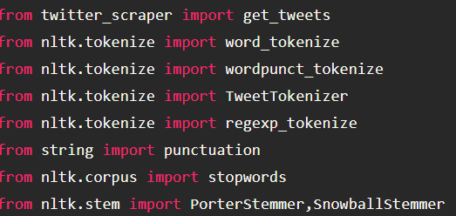

*Screenshot 1: Importing Libraries*

**Step 2: Extracting Tweets:**

I have Implemented this using two approaches to demonstrate Extracting tweets.

In **Scenario 1**: I am extracting tweets using the *twitter_scraper* library using the #as twitter followed by page number as 10.

In **Scenario 2**: I have extracted the tweets (10 tweets) from an Excel File.

My Intention here was to demonstrate flexibility in the extraction of tweets onto the Jupyter Notebook console.

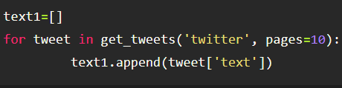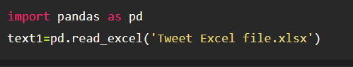

**Step 3:** In this step I had to decide the usage of Algorithms to get relevant output. Before application of algorithms it is very Important to ensure the Data is Cleaned.

**Latent Dirichlet Allocation:** I am now using the LDA Algorithm for topic modelling that is used to generate topics based on word frequency from a set of documents. It is useful in finding similarity features from the set of text data.

**The Principal Component Analysis:** I used this Algorithm for the dimensionality reduction feature**.**

Finally, I used the **K-Means Clustering Algorithm** to display the Desired output.

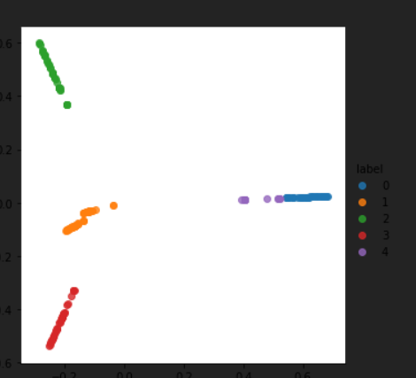 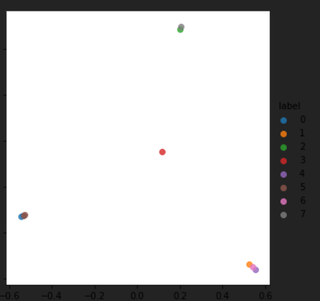

**Output 1** **Output 2**

'Does the cluster indicate relevant tweets?'

**Answer:** I have considered both the possible scenarios to answer this question in detail. Below is my answer indicating both the possible output.

***Output 1:***As seen above the density of output 1 is better and spread over plethora of tweets. This is because I have used 10 pages of tweets rather than only 10 tweets for output 1. The Labels [0-4] indicate the tweets plotted using the K-Means Cluster. As Per the spread the cluster clearly has grouped all relevant tweets together with each label indicating different shade of colour per tweet. Therefore, I conclude the cluster Indicates relevant tweets.

***Output 2:*** As seen in the above screenshot, the density of the tweets is lesser as I am displaying the output for only 10 tweets in output 2. The labels [1-7] Indicate different colors per similar tweets. However, as seen the tweets are not forming a clear/Exact cluster (as seen the colors are mixed among each other indicating tweets are not fully relevant compared to Output 1). Therefore, I conclude the cluster Indicates partially relevant tweets only.

**Please Find Attached:** Python Jupyter notebook as well as .html file for your reference.